St Catherine’s Early Education Centre
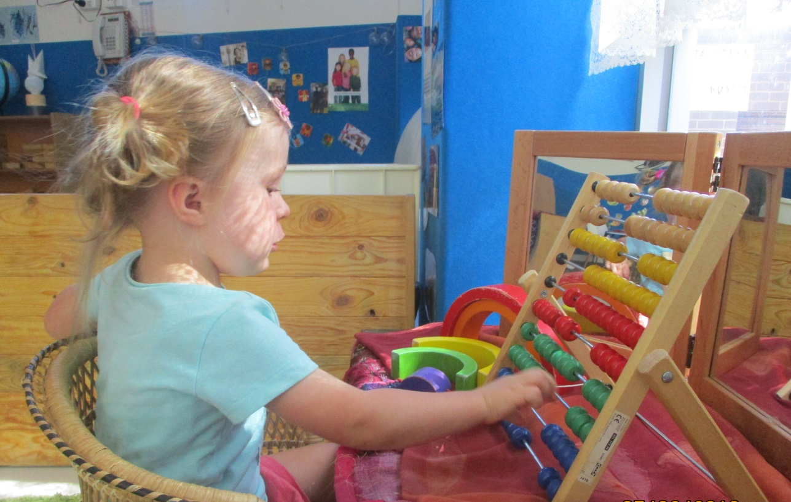
Parent and Family Information Book
Connecting with children, families and the community

35 Canning Street, North Melbourne, 3051
info@seec.com.au
Ph: 93283040
Monday – Friday 7:00am-6:30pm

Acknowledgement of Country

On behalf of St Catherine’s Early Education Centre, we wish to acknowledge the traditional custodians of this land on which we gather daily, the Wurundjeri people of the Kulin nation. We pay respect to Elder’s past and present.
We aim to create a positive awareness of indigenous culture and heritage within our children’s programs through learning activities including books, songs, dance, art, craft and puzzles and building relationships and networks with the local Indigenous community and Elders.

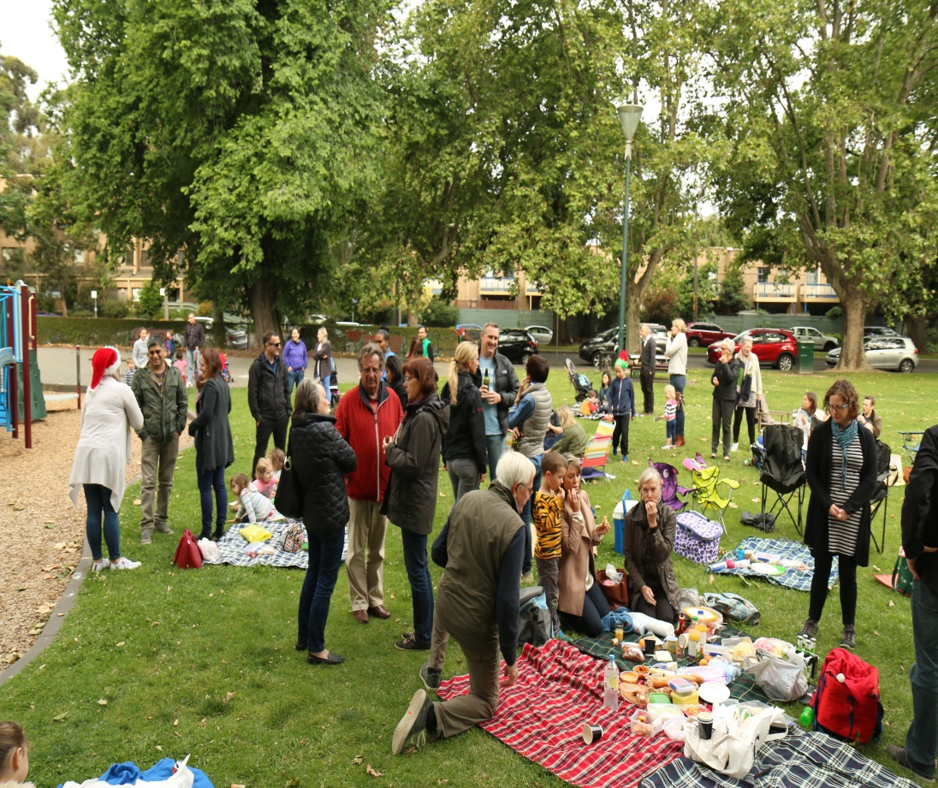

I would like to extend a warm welcome to you from all the educators and staff at St Catherine’s Early Education Centre. For many parents, leaving their children in someone else’s care can be a very stressful time. We want to work in partnership with you to make the transition into Childcare and Kindergarten as stress free as possible. Having worked as a young mum, I remember the worry I felt when leaving my children for the first time. Therefore, I want to work with you to ensure you are able to go about your day, without feeling worried about leaving your child at our centre. Our doors are always open and you are welcome to visit the centre and experience the programs we have on offer. We work hard to make you feel at home and apart of the St Catherine’s community, ensuring you feel comfortable to visit or contact us at any time. Partnership means working together, so both your input and feedback are essential in order to maintain the high quality of care and education for your child. Please feel free to contact our St Catherine’s team and myself at any time if you have questions, queries or comments. We look forward to beginning this journey with you and your family.

Welcome to our community
The management and staff at St Catherine’s Early Education Centre welcome you to the family. We trust that your time spent with us will be a happy and fulfilling experience.
We provide:
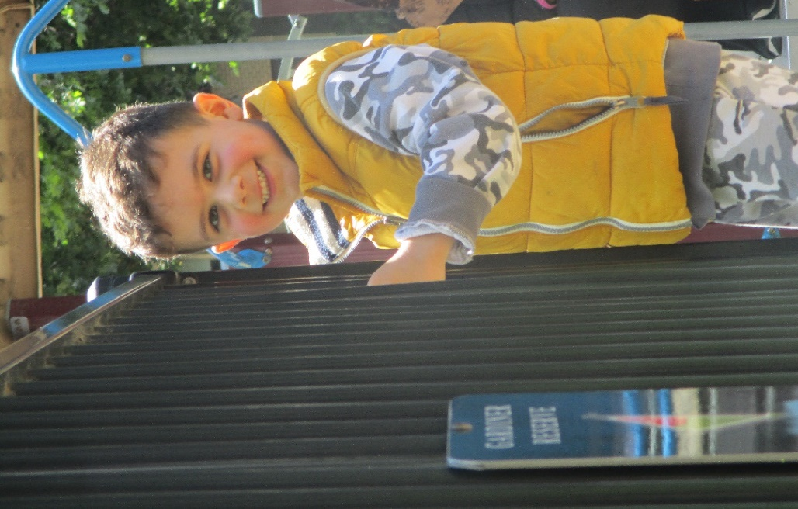
Long Day Care/ Kindergarten funded program
Balanced nutritious meals including:
Breakfast
Morning Tea
Lunch
Afternoon Tea
Late Snack
Supplied nappies
Sun Hats and Sunscreen
Air-conditioned facilities
Indoor Outdoor Program
Development portfolio for each child
Age appropriate services and facilities
Early Childhood Professionals

We operate Monday to Friday, 51 weeks of the year (apart from gazetted public holidays) and shut between Christmas and New Year’s Day.
Operating hours are between 7:00am and 6:30pm
Our staff at St Catherine’s Early Education Centre are always available to discuss any questions or respond to any concerns you may have during the orientation process and beyond. Please feel free to approach the staff at any time.

Please take the time to read this handbook as it will give you an insight into the philosophy, goals and routines within our centre. It will also explain our policies to aid in a smooth transition into the centre.

St Catherine’s Centre structure
St Catherine’s Early Education Centre is a not for profit centre that is owned by the Ukrainian Catholic church in Australia and the Approved Providers. We report to and work closely with the Directors of the Eparchial Finance Committee.
We have a strong management team consisting of a non-ratio Director of Children’s Education and Wellbeing (Centre Director), Assistant Director and Director of Business. We employ approximately 21 staff across the week.

Approved Provider
Trustees of the Ukrainian Catholic church
Educators & Staff
Certified Supervisors
Assistant Director and Educational Leader
Dianne Sievers
Responsible Person
Nik Kohut
Director of Education and Care
Jennie Madden
Director of Business
Felix Figurek

Our Philosophy
St Catherine’s Early Education Centre will be inventive and unique to ensure that we, St Catherine’s community are distinctive within the early childhood education field.
“We would like to acknowledge the Wurundjeri people who are the traditional custodians of this land. We would also like to pay respect to the elders past and present of the People of the Kulin Nation and extend that respect to all Aboriginal and Torres Strait Islander people.”
At St. Catherine’s we value and work under the Nation quality framework guiding principles and National quality standards. In delivering our Education and Care curriculum, we follow the principles, practices and learning outcomes of the National early year’s framework.
Our Vision
We recognise the uniqueness of each child and the importance of play in the lives of children. We will, working in partnership with families be committed to providing exceptional education and care within a welcoming environment that embraces diversity and the local community.

We will deliver the highest level of care and education for your child in a warm, nurturing and safe environment.
We will respect the children’s rights to feel safe, secure and comfortable in their environment. We will listen and respond to their feelings and needs as required.
As educators we will work together to create a welcoming environment that the children will want to be a part of.
We will treat all children equitably and give each child an opportunity to develop skills for life-long learning focusing on each child’s strengths and interests.
We will create opportunities for children to build friendships, laugh, smile and jump in puddles.
We will respect and respond to the needs and interests of each individual child and continually encourage children to develop an understanding of who they are and how they fit into the world.
We will continually encourage and support the development of self- esteem, confidence and independence of children.

We will work in partnership with families to build relationships based on co-operation and a mutual respect for the reciprocal roles that each play in the lives of the children.
We will encourage support and guide all families in an inclusive environment filled with wonder and awe.
We will include and work towards parent’s goals for their children, and consider them valuable.

We as a team, through our leadership and management, encourage educators to work collaboratively by sharing knowledge and experiences.
We will as educators work with the children to discover ideas and provide opportunities for learning through emergent intentional teaching.
We will provide an inclusive environment and aim to increase the children’s awareness and respect of cultural differences.

We value belonging to the North Melbourne community and will involve our centre in the diverse cultures, communities and events that make up the local area.
We will engage with our community and encourage the children, families and staff to be part of the cultural events and celebrations that occur.
We will expose the children to different members of our community.

Enrolment
A completed Enrolment Booklet must be returned to the centre before care can commence.
Under Family Assistance Office guidelines, in respect to Child care subsidy there are guidelines to Priority of Access to Care, which are:
- Workforce participation and Training
- Children with disabilities
- Children at risk
- Parents at home
Immunisation
Before we can confirm the enrolment of your child, the parent/carer must provide an immunisation status certificate that shows their child:
- Is up to dare with vaccinations for their age OR
- Is on a recognised vaccine catch up schedule OR
- Has a medical condition preventing them from being fully vaccinated?
We can assist families of children who are not up to date with their immunisation with support and information resources as to where they can access vaccinations.
Local council immunisation nurses, GP’s and health clinics can provide immunisation services.
Immunisation Schedule 2018
- No Appointment necessary
- Bring your Medicare card and your child’s Health and Development Record book and/or overseas vaccination record.
- Be prepared to remain at the venue for a minimum of 15 minutes post vaccination to ensure your child leaves in good health.
North Melbourne Library
Level One, 66 Errol Street
Day & Time | Jan | Feb | March | April | May | June
Tuesday  10:00 – 11:30am | 16 | 13 | 13 | No session | 15 | 12

New Families arriving from overseas
If you are a new resident in the City of Melbourne and require vaccine catch up, a school or childcare entry immunisation statement or updates to your child’s history on the Australian Immunisation Register, please send your child’s vaccination records (in English) to: immunisation@melbourne.vic.gov.au Please do this before attending an immunisation session.

Fees
The daily fee is $120.00 per day, or $600.00 per week
It is our policy that all families pay an enrolment bond of two weeks’ fees upon securing a booking. This is non-refundable if you decide to cancel your booking, before commencing care.
When we receive your 2 weeks’ notice to cease care your bond will be added to your account to cover all or part of your remaining fees.
Parents must pay the weekly fee and a week in advance in order to maintain a credit balance equivalent to two weeks of fees. It is recommended upon enrolment that fees are paid via debitsuccess (credit card/direct debit). All families must complete a banking application form upon enrolment. Please ensure payment is made on time, or a Dishonour fee of $15.00 will apply for late payment. There is a review of fees every June the following year.
The following outlines how the fees can be paid:
- Fees can be paid weekly, fortnightly or monthly in advance by debitsuccess
- Fees are payable in advance for everyday that your child in enrolled at the service. This includes public holidays, sick days and family holidays but excludes periods when the service is closed.
- Child care subsidy is available to all families who are Australian Residents and meet income requirements.
To find out about eligibility. Families must contact the Family Assistance Office (Centrelink)
www.humanservices.gov.au
Child care subsidy will be a reduction of fees through the service.
Child are subsidy
2nd July 2018
- On the 2nd July, the new childcare package was introduced.
- All families must have a myGov account set up.
- To find out more visit www.education.gov.au/childcare
Should you wish to end your child’s place at our service two weeks’ notice is required in writing. If this does not occur, two weeks’ fee will still be billed to you. Please note that once you give notice you must still attend care in order to receive any government benefits. If you fail to attend during the notice period child care subsidy will not be paid by the government.
If you need to make a change to your booking to reduce days, two weeks’ notice is to be given.
All holiday periods will be charged at normal childcare rates unless you give the required 2 weeks’ notice and then you will receive a 20% discount for holiday periods of a week or more. NO SINGLE DAYS

Late Fees
Late penalty fee applies if children remain in the centre after closing time at 6:30pm. We are licenced from 7:00am-6:30pm.
The late fee is a flat rate of $45.00 for any part of 6.35 to 6.45pm after 6.45pm the rate is a flat $120.00.
If you are running late please phone the centre to make the staff aware and they can explain to your child as we are seeing children becoming aware they are the only ones left and educators trying to contact parents that are not answering phones. Please note that this does not waiver the late fee.
Arrival and Departure
Each child must be signed in and out of the centre every day they attend. This is a legal requirement that we must follow. These records are used in case of emergencies and for the calculation of the Child Care subsidy (CCS)
On arrival at the centre, you are asked to do the following:
- Every morning sign your child in using the ipad
- Present your child to the an educator
- Say goodbye to your child.
Before you leave the centre at pick up, you are asked to do the following:
- Come into the room and greet your child
- Collect your child’s belongings
- With your child say goodbye to the educators in the room
- Sign your child out using the ipad.
Collection of Children
No child will be released into the care of any persons not known to educators. If the educators do not know the person by appearance, the person must be able to produce some form of photo identification to prove that they are the person authorised to collect the child on the enrolment form.
In the event that a child has not been collected 5 minutes after closing time then the parent/guardian or emergency contact will be contacted on the emergency telephone numbers.
If the child has still not been collected 15 minutes after closing time, and there has been no contact with the family, educators will notify the centre director who will then make decisions based on the best interest of the child.
If you are running late, stuck in traffic or train delays please call the centre immediately, we will know there is someone on the way. (Sometimes each parent thinks the other is picking up the child, it’s only later when they get home they have realised the miscommunication.)
Absences
Parents are requested to phone the centre if their child is unable to attend their session for any reason. Notice is also required in the incidence of infectious or contagious diseases in the family.
Families receiving Child Care Subsidy are allocated 42 absent days for each child per financial year. These absences can be taken for any reason and also include Public Holidays. Once the child has reached 42 absent days, CCS is not paid for any further absences, unless the absences are taken for an additional absence reason such as:
- Illness (with medical certificate)
- Parent with rostered day off (Statutory Declaration signed by a J.P required)
- Parent with rotating shift (Statutory Declaration signed by a J.P required)
- Temporary closure of a school or pupil free day
- Periods of local emergency
- Court ordered shared custody
- Attendance at pre-school
There is no limit on the number of additional absence days a child’s family may claim providing they are taken for the above reasons and have documentation/evidence.

Health and Wellbeing

Accidents and Incidents
Our staff organise both the indoor and outdoor environment to promote safety and allow for maximum supervision, in order to prevent any accidents to children and staff. In the case of an accident involving your child whilst at the centre, staff will immediately administer First Aid. If the injury requires further medical treatment, you will be contacted and a plan of action organised.
If a parent or emergency contact cannot be reached, the Director/person in charge will act on behalf of the parent and proceed with whatever medical treatment is required. A staff member known to the child will accompany the child to the doctor/ hospital and stay with them until the parent arrives. Documentation of the accident will be made on an Incident Report Form.
If the child has an injury about the shoulders, is bitten or is bleeding we will notify the parents by phone. If the injury is a minor scrape or bump an incident form will be filled out and you will be notified at pick up time.
Illness
If your child becomes unwell with a fever of 38 degrees or above we will call you immediately to pick up your child. If your child complains about an ache we will monitor it and your child closely for 30 minutes. If no improvements occur we will contact you to let you know what is happening and may ask you to collect your child if they are too unwell to participate in the program. An illness form will be available for you to sign upon arrival.

Medication
If your child requires medication whilst at care, a medication form must be filled out by a parent in all required areas clearly and signed. The medication must be accompanied by a prescribed label or doctors letter which states who the medication is for and the dosage. Medication must be handed to a staff member and will be stored in a locked box or refrigerator. Under no circumstance is any type of medication to be left in the child’s bag.

Nutrition
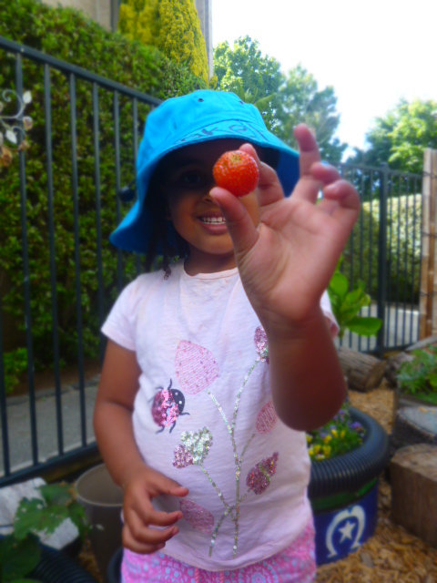
Children in long day care may receive 50% to 70% of their daily food intake whilst in care. It is essential that adequate nutrition in proportion to the time spent in care is important. Therefore, the children at St Catherine’s are provided with five meals a day and each meal if freshly prepared daily. Please see our director, Jennie regarding any meals that are supplied at the centre. You will also find our menu cycle on the foyer notice board, and please be aware we are a nut free centre.

Sleep and Rest
Most children benefit from periods of rest, which helps them grow and ensures their learning and development is nurtured. Our service implements rest periods, which are consistent with the developmental needs of the children and their age; this includes a short period of rest each day for our older rooms.

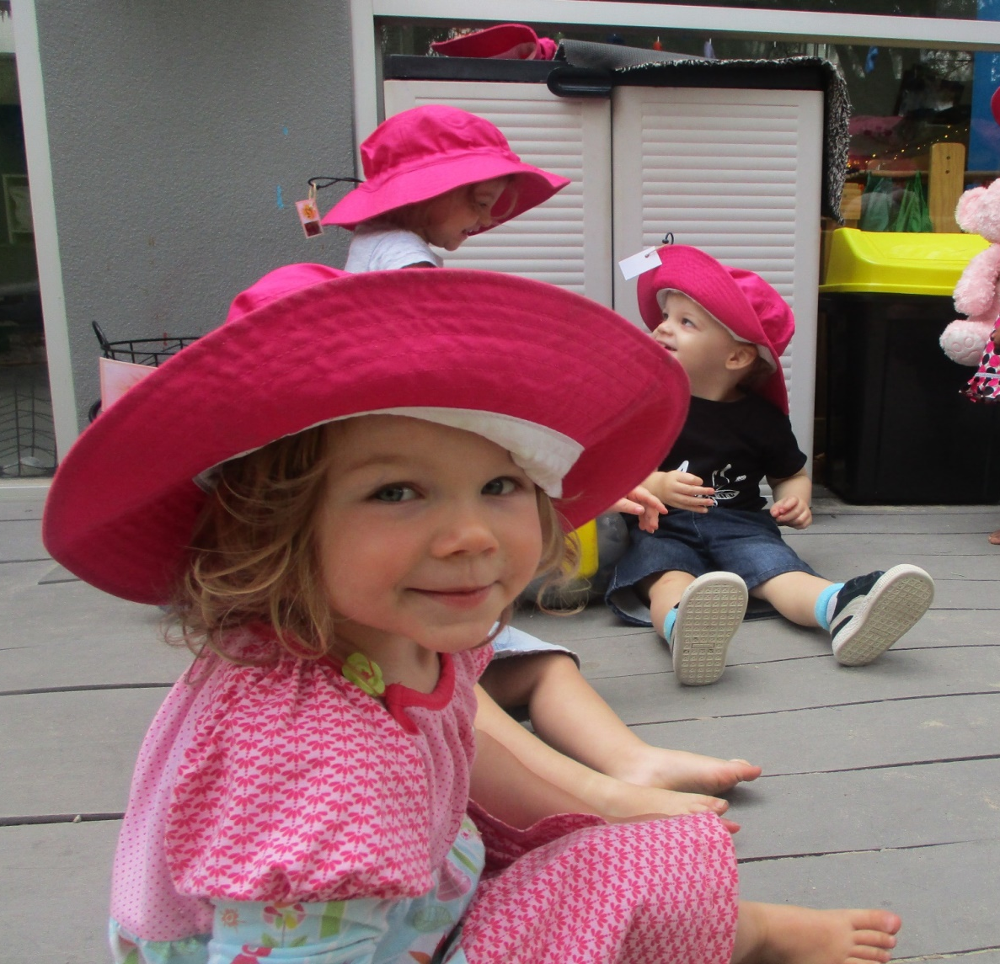

Sun Protection
We are a SunSmart centre
We ensure that we protect our children and educators from direct exposure to the sun. This is extremely important as children are very vulnerable to sunburns, which can increase their chances of acquiring skin cancer by almost 50%. This is one of the most common forms prevalent in Australia and skin damage from sunburn can never be repaired.
Every child is supplied with a bucket hat each year. Shoulders must be covered on all children and sunscreen applied each time we venture out but also every four hours. We check the UV on the Sun Smart app for the recommended sun protection times.
Our centre abides by all state regulations and the child care building code in regards to the amount of manufactured and natural shade available in the playgrounds. Shade structures are maintained in the annual playground improvement plan and regular maintenance is conducted as required, initiated by our centre director.
Fire and Emergency Policy
Regular fire drills are held at the centre and quick evacuation is ensured in the event of a fire. Fire extinguishers are strategically located throughout the centre. As part of our fire safety measures all children in attendance at the centre are noted from the attendance sheet. Each child is identified during a fire drill. This is why it is important to sure that you always sign your child ‘IN’ and ‘OUT’ of the centre each day. We will have a note on the sign in/out sheets of an afternoon if we have held a fire drill.
Health
To minimise the spread of infection in our centre, children suffering from certain infections are excluded from attending child care depending on the infection. The exclusion periods are displayed in the parent information area. If a child in care has a suspected infectious condition, the parents will be contacted and asked to collect the child as soon as possible. Parents are encouraged to seek medical advice and contact the centre informing us of the outcome.
Children with a suspected infectious condition must produce a medical certificate if the doctor believes they are not contagious before the child returns to care. The centre will inform all families of any infectious outbreaks and post signs which include symptoms and exclusion time from the centre. Your child must not return to care until 48 hours after the last symptom has occurred.
The director will not accept a child into care if they are not well enough to participate in normal activities or require special attention because of ill health.
Please refer to our infectious diseases policy for further details
In the case where a child has a high fever, staff are only able to administer Children’s Panadol once parents have given verbal permission over the phone to two staff members. Parents will be informed of this and documentation will be kept on file. Once a child’s temperature reaches 38 degrees parents will be asked to collect the child immediately.
Panadol will not be kept on premises. In an emergency the centre will purchase a bottle of Panadol to use for your child and you will be billed accordingly.
Car Parking
We ask that all parents use the centre car park located off Norris lane, on Dryburgh street. Please travel at a safe speed remembering there are many small children coming and going. If the car park is full please use the alternative drop off area in Dryburgh street. Please remember we have neighbours and try to keep the noise to a minimum. We also ask you do not park besides our building as reversing out could be dangerous. Please do not keep your car in the carpark for the day, as our educators require parks also.
Do not leave children in cars unattended

The First Weeks

The introduction into long day care can be difficult for children and parents. Children’s welfare and happiness are the priority of our educators when welcoming new children to the centre and when assisting the family to settle into the centre environment. It is recognised that family’s needs will vary greatly in the orientation process and individual needs will be met. The following outlines some helpful hints for parents on settling their child into care:
- Make sure you familiarise your child with the environment and the people in the environment (children and adults) by coming in for visits before commencing care.
- Ease your child into care with short stays to begin with, an orientation program will be organised when you first enrol that is free of charge.
- Provide a favourite toy, blanket or comforter to support your child when they are separating from you or settling into sleep as this will help your child to feel more secure.
- If your child is unsettled, short visits with your helps your child to gain trust in with an unfamiliar environment, these visits can be made on a day when your child is not booked to attend.
- Interactions between educators and parents or educators and other children can help a child to be reassured and provide as positive role modelling. This experience can help to establish trust in an unfamiliar setting.
- Try to talk at home about child care, mention the names of the educators and other children to help them feel more familiar and comfortable. Talk about the things the child will be able to do whilst at children that are fun and enjoyable.
- Talk to the educators about your child, for example, what their interests are, successful ways of settling them to sleep, foods they like and dislike. This helps educators to get to know your child.
- When leaving your child, it is best to make sure you say goodbye and then leave. Hesitating and not going after your have said goodbye, if a child is upset, only confuses them. Reassure your child that everything is alright and your will return later, this will help them to settle.
- It sometimes helps to establish a routine when leaving, for example, giving your child a cuddle and giving them to an educator or sitting down with them for a short play or reading a book together before leaving.
- At first, some children protest strongly while others may take a day or two to realise that you are leaving them and begin to protest after several days. Children soon learn that you do return and in the meantime, they are well cared for.

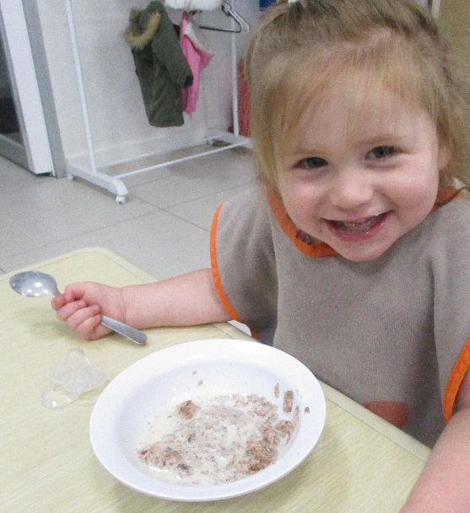

We aim to ensure that you and your child settle in and enjoy our centre experience
- We offer two half-day orientation sessions, yet some children may need a couple more. During this time, we ask parents to stay on the premises. We have an upstairs area where you may have coffee, tea and a biscuit, use the Wi-Fi or watch television if you wish. You can wander down at any time to see how your child is.
- Settling in is tailored to meet the individual needs of each child and their family.
- The educators play an active role in gathering information from you and your family so we can then determine what is best for your child.
- We do this, as our aim is to make the transition between home and the centre as smooth as possible: hence, the partnership between the parents and educators is important.

Once your child has commenced care
- Our educators are always available to regularly discuss your child’s day
- We encourage you to spend time with your child to settle them in and you are more than welcome to phone us during the day to check on your child’s progress.
- We assign a primary caregiver to assist in settling your child in each day and help them to overcome any anxiety they may be feeling.
- We aim to ensure that all staff know your needs and work together as a team to provide routine and consistency of care.
We are partners
Success in early childhood is a goal that both parents and educators have for their children. Learning improves when parents are involved in their child’s care and education.
When parents work in partnership with their child’s educators, the child clearly benefits as the educator can have a greater understanding of the child’s family history to cater towards the child’s needs.
So how can educators and parents work in partnership?
There are many things parents can do at home. Encouraging a positive attitude towards learning is one of the biggest favours a parent can do for their child. Educators appreciate it when parents:
- Help their child understand that learning is important
- Set expectations for learning, by taking into account their child’s ability
- Show an interest in what their child is learning and what is happening at the centre. Remember at this age, learning is often done through play!
- Reading the memos and information sheets that are sent home or displayed on notice boards. Taking notes of important dates on our calendar also.
It is important that educators and parents get to know each other to develop trust and respect.
Children succeed when there is an open exchange of information that links the home with the centre.
- Exchange ideas about the child’s special talents and hobbies. We can then focus the child’s learning through interests, strengths and weaknesses.
- Inform the educator if the child has a medical condition that may affect the child in care (asthma, allergies, diabetes to name a few). Educators are not medical practitioners and parents should discuss arrangements they have made for emergency situations with our staff.
- Talk with the child’s educator about what is being taught.
- Discuss things like expectations. Explore ways that the parent and educator can help the child meet those needs.

Please let the educators know about situations, which might affect the child’s interest in the centre. A seriously ill grandparent, the arrival of a baby or changes in a work situation can be upsetting to a child. Educators are better able to provide learning experiences for children if parents let educators know what is happening.

Parent Participation
This is vital to ensure maintenance of a quality service. Your contribution of ideas, experiences and skills are welcomed and greatly valued. You may be able to share your skills and experiences in music, craft, cooking and storytelling etc, to enhance your child’s program at our centre. Please complete your availability or what you can offer the centre on the enrolment form.
Parent-Educator
Communication is important to us. Parents will be provided with information about your child’s day, including learning that has taken place, rest and meals provided.
Our educators with also speak with you informally upon collection of your child or through phone calls if any issues arise during the day. Educators are readily available to discuss with parents the achievements and concerns of the child. We have portfolios for each child. These are documentations reflecting the child’s individuality throughout their time at the centre. Just like the children as they grow so do their portfolio’s, which is always a continuation.
However, the following matters are often discussed
- All areas of development for the child – samples of work may be shown
- The parents and educator’s expectation for the child
- How the educator evaluates progress
- Joint development of a plan to help the child overcome any problems and to continue important accomplishments; and how parents and educator’s can work together on a continuing basis to encourage the child to do well.
Please feel free to contact us at any time by phone, email or in person to discuss your child’s progress, relationship, interest and experiences.

When great things happen
Please tell us! Compliments reinforce the good things that are happening in the child’s life, either at home or at the centre. Keeping in touch and working together is the best way to ensure a high-quality education for our children, and to help ensure their success not only in the centre and the early years but also in life.
We encourage parents to actively participate in the care of their children through involvement in decision making with regard to their child’s care and education. Parents are welcome to spend time in the centre and share special occasions with their child. Please speak to your child’s educator for more information.
Parent Grievances
Our staff are here to ensure your child is happy and healthy in their care. If there is a problem that arises that you feel you need to resolve with our staff, then please let us know.
Our grievance policy is displayed in the centre foyer, however if you have a grievance the first point of contact should be the Room Leader of your child’s room. They will work with you to resolve the problem.
If you feel that further resolution is required, the please speak to our director, Jennie who will help you and the Room Leader to resolve the problem.
All grievances will be taken seriously and our best efforts will always be forth coming. All outcome will be documented and hopefully happy ones.

Guiding Children’s Behaviour
Educators, in partnership with parents aim to ensure all educators form positive relationships with children that make them feel safe, secure and supported whilst at St Catherine’s. Educators will encourage positive relationships between children and their peers as well as with educators and volunteers within our centre.
Children are encouraged to develop skills that will allow them to resolve conflicts and meet their needs without the use of aggressive or destructive behaviours. Children are encouraged to respect themselves and others. When team members guide a child’s behaviour they should aim to provide the child with clear guidelines and boundaries.

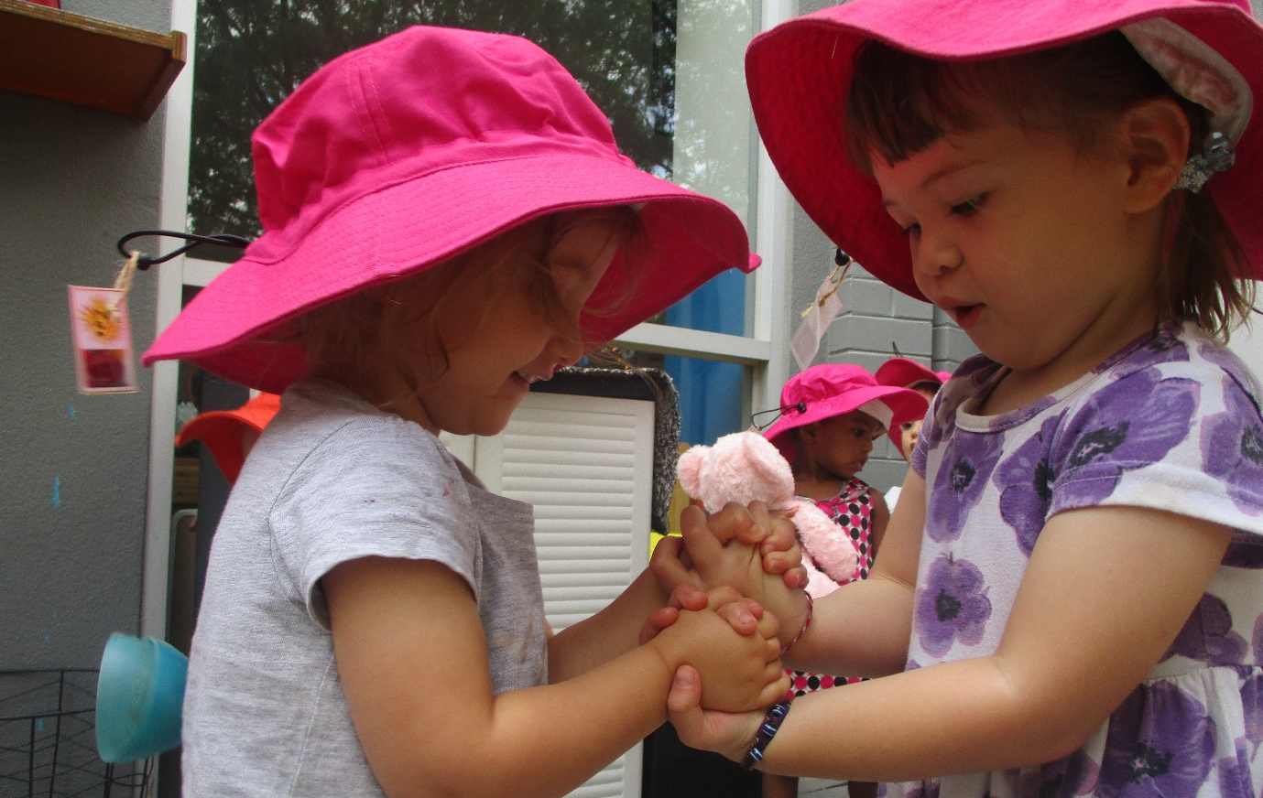
What should you bring
A change of clothes that is weather appropriate, younger children especially those toilet training will need extra changes of clothing. Please ensure all clothes are named
What should you bring
- A security item for rest time or when required
- Babies bottles will need to be brought to the centre made up ready to drink with formula, alternatively you may bring an unopened tin of formula to keep at the centre. Educators will make the formula following the tins directions. Bottles must come with boiled water (cow’s milk will be supplied). Breast milk can be supplied daily if you are unable to come into the centre for breast feeds, we do require you have a spare in our freezer at all times.
- Gumboots and coats in winter
- A labelled water bottle

Clothing
- Parents are advised to send their children to the centre in comfortable, inexpensive clothing. The children need to be able to move around during their play period and should be unimpaired by clothing. While paints etc will come out in the wash, accidents do happen so it is best to send your child along in their “less than good clothes”. Young children enjoy and need messy play with plaints, clay, sand, water and mud.
- The centre will only have a limited supply of spare clothing. Please supply at least one change of clothing and underclothing in case of accidents.
- Please mark your child’s clothing and replace name tags if they fade in the wash. Ensure clothing is weather appropriate. Please ensure that toddlers have about three complete changes of clothing and plenty of underpants.
- Singlet tops, shoe string dresses and thongs are not permitted in warmer weather. We are a Sun Smart centre. Please ensure all belongings are clearly labelled such as dummies, clothes etc
- Lost property will be displayed for parent collection in your child’s room. Parents cooperation in labelling assists the centre in keeping your child’s belongings together.

Lockers
- Every child may choose a locker daily, located outside their rooms. Please place bags, etc in your child’s locker along with their tags.
- All medications are to be removed and handed to a staff member.
- Please ensure no items that pose a danger to children are kept in children’s bags or locker.

Partnerships with Families
- We will work in partnership with families to build relationships based on cooperation and a mutual respect for the reciprocal roles that each play in the lives of the child.
- We will encourage, support and guide all families in an inclusive environment filled with wonder and awe.
- We will include and work towards parents goals for their child and consider them valuable
- We welcome all input and participation in the program.
Everybody has a different communication style and time for communication. We understand that and welcome your approach.
You’re given lots of information about what is happening and asked for your views, we hope for your involvement in all aspects of the centre.

Communication and educators
Morning and Afternoon can be a little rushed, and not the best time to discuss your child. We have many types of communication we use for families in the centre just like you. Just let us know what you prefer
- Newsletters
- Emails
- Face to Face
We will attempt to speak to all parents at drop off and pick up times, we value your time
Confidentiality and Privacy
St Catherine’s Early Education centre aims to protect the privacy and confidentiality by ensuring that all records and information about individual children families, educators and management are kept in a secure place and are only accessed by or disclosed to those individuals who need the information to fulfil their responsibilities at the service or have a legal right to know.
Information received through written and spoken communication with families will be treated with discretion. At any time if you require a private discussion with our staff please inform us. This can happen either face to face or over the phone.
Please refer to the Confidentiality and Privacy policy for further information

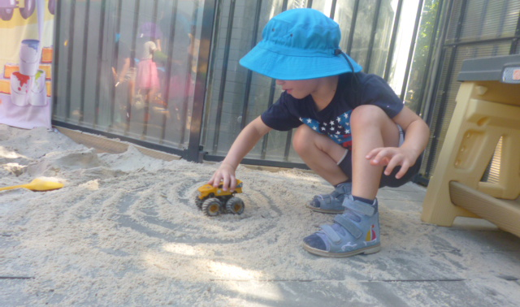

Our goals are clear
Our goals for children in our care
- To provide a safe, happy and healthy environment, which recognises the special needs and talents of individual children through the employment of caring and qualified educators.
- To ensure that all aspects of each child’s developmental needs are programmed for and periodically assessed.
Our goal for our families
- To provide support for families through the provision of high quality education and care, as well as resources
- To involve parents in decision making about centre policy development, staffing and general centre management to as great a degree as possible
- To provide services to families with different economic, cultural and ethical backgrounds, preventing segregation on the basis of any of these factors, and always respecting the individual rights of all families.
- To support regulations governing children’s services
Our goal for our staff
- To promote ongoing training and professional enrichment to all staff with opportunities for career advancement wherever possible
- To promote secure, supported employment through sound industrial rights, conditions and personal practices.
Our overall goals
- To research and plan for children’s services
- To promote community awareness and understanding of quality children’s services.
- To liaise with Federal, State and Local Government regarding funding, licensing, guidelines and responsibilities.
- To provide children’s services which are accountable to users, and responsive to their needs and the needs of the local community.
We aim to develop in each child the ability to:
- Feel confident
- Be independent, learning self-help skills
- Promote the child’s gross and fine motor skills
- Communicate with others
- Learn to cooperate as part of a group, to share and take turns
- Express oneself through speech, movement, music and art
- Observe, explore, question, reason and problem solve
- Share ideas and opinions
- Be eager for new experiences

Educational Program
Early Years Learning Framework
Our qualified educators plan experiences which develop children’s skills in all developmental areas and are part of the Early Years Learning Framework. This framework puts children’s learning at the core and compromises three inter-related elements: Principles, Practice and Learning Outcomes. All three elements are fundamental to early childhood pedagogy and curriculum decision making. Fundamental to the Federal Government’s framework is a view of children’s lives as characteristics by Belonging. Being and Becoming.
The framework conveys the highest expectations for all children’s learning from birth to five years and through the transition to school. If communicates these expectations through the following five Learning Outcomes.
- Children are confident and involved learners
- Children have a strong identity
- Children have a strong sense of wellbeing
- Children are effective communicators
- Children are well connected with and contribute with their world
Play activities planned by our educators allow children to naturally develop and have the opportunity to guide their own learning. Outcomes and individual observations on your child are documented in your children’s files to assist in extending their skills and abilities.
Children have the opportunity for both indoor and outdoor play as part of each group’s routine. The outdoor area is an essential part of the learning environment for children, and often allowing for sensory exploration. All age groups utilize our specifically designed playgrounds to test their co-ordination, balance, skills and strength.
Working in partnership with families our educators use the learning outcomes to guide their planning for children’s learning. In order to engage children actively in learning, our educators identify the children’s strengths and interests, choose appropriate teaching strategies and design the learning environment.
Our routines allow times for individual, small group and large group learning and play. Children’s language and literacy skills are further developed during these times as children are involved in storytelling, drama, poems and games. Music also plays a large part during these sessions as children are able to experiment with dancing, singing and exercising their bodies.

Funded Kindergarten Program
School Readiness program
St Catherine’s offers a School Readiness program based on the National Early Years Learning Framework. The Framework has a strong emphasis on play-based learning, as play is the best vehicle for young children’s learning providing the most appropriate stimulus for brain development. The Framework also recognises the importance of communication and language (including early literacy and numeracy and social and emotional development).
We believe the value of play is of utmost importance to children as children as it is their way of learning about their world. While children are playing they are able to express their creative ability, release emotions and can share their feelings. We aim to guide your child in becoming an effective learner through creating an environment that is challenging and stimulating.
We allow children to make choices for themselves it an important yet relatively easy step towards encouraging independence and agency. When we make materials and resources easily accessible without the need for adult assistance, we promote children’s ability to resource their own learning, independently and successfully.
The overall aim of our program is to help your child in developing all areas necessary for success now and in the years to come.
Our Kindergarten program is designed to improve your child’s development in the following key areas:
- Social skills, like how to play with other children in a calm, sharing and rewarding way
- Self-awareness and respect for others
- Emotional skills, for example understanding their feelings
- Language, literacy and numeracy skills, such as talking, drawing and making things together with other children their age
- Ability to make new friendships
- Exposure to new ideas and concepts
National Quality Standard rating
ACECQA is responsible for administration of the National Quality Standards (NQS) system for children’s services throughout Australia.
All childcare centres participate in NQS and are eligible to receive funding from the Australian Government (currently Child Care Benefit).
The broad objective of ACECQA is to guide the implementation of the National Quality Framework for Early Childhood Education and Care nationally and ensure the consistency in delivery across all services.
All childcare centres participate in the NQS validation process and as of 20th November 2017, St Catherine’s Early Education Centre was assessed as Exceeding the NQS. For further information on the NQS process please speak to our St Catherine’s management team.

Friendly Reminder on what to bring on your first day
- Enrolment Form, ensuring all sections are complete
Immunisation Statement
- Water Bottle
- Adequate spare clothing & underwear
- Milk Bottles
- A tin of Formula
- Any comfort items
Please remember to label everything and we look forward to getting to know your family

All policies are located in the Policy folder within our Parent & Visitor library at your disposal.

